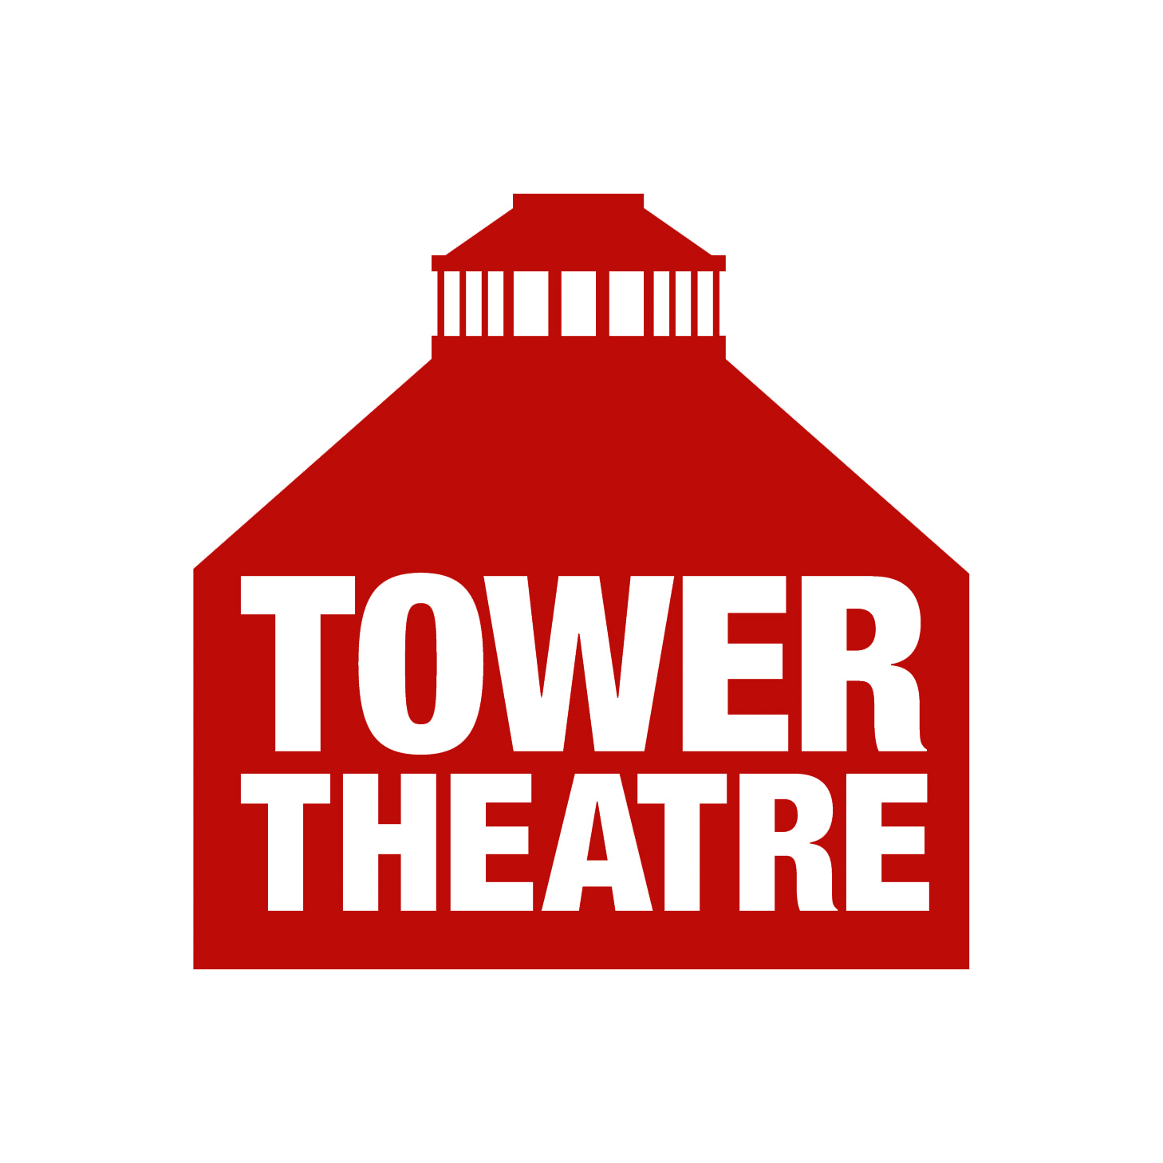 | PRODUCTION RISK ASSESSMENT  Show title: Venue:  Performance dates:  Director:  Set Designer:  Stage Manager:  Lighting Designer:
RISK ASSESSMENT MATRIX |  | POTENTIAL CONSEQUENCE OF HARM
 |  | 1 – Minor Injury  (e.g. hazard can cause illness, injury, or equipment damage but the results would not be expected to be serious) | 2 – Significant Injury  (e.g. hazard can result in serious injury and/or illness, over 3-day absence) | 3 – Major Injury  (e.g. hazard capable of causing death or serious and life threatening injuries)
Likelihood of harm | 1 – Unlikely | 1 – Low | 2 – Low | 3 – Medium
Likelihood of harm | 2 – Possible | 2 – Low | 4 – Medium | 6 – High
Likelihood of harm | 3 – Probable | 3 – Medium | 6 – High | 9 – Extreme

RISK EVALUATION
This is calculated by multiplying the likelihood against the consequence e.g., taking a likelihood of 1, which is classified as Unlikely and multiplying this against a Potential Consequence of 2, which is classified as Significant Injury, would give you and overall Risk Rating of 2, which would result in an overall evaluation as a low risk.
1 to 2 = Low risk
Low risks are largely acceptable, monitor periodically to determine situation changes which may affect the risk, or after significant changes
3 to 4 = Medium risk
Medium risks at the upper end of this band should only be tolerated for the short-term and then only whilst further control measures to mitigate the risk are being planned and introduced, within a defined time period. Risks on the lower end should be reduced if practicable.
6 = High risk
High risks activities should cease immediately until further control measures to mitigate the risk are introduced. The continued effectiveness of control measures must be monitored periodically.
9 = Extreme Risk
Work should not be started or continued until the risk has been mitigated. Immediate action is required to reduce exposure. A detailed mitigation plan must be developed, implemented and monitored by management to reduce the risk before work is allowed to commence.

For further advice please contact:
Health and Safety Officer:
POTENTIAL RISKS

- REHEARSAL RISK ASSESSMENT
Description of activity/associated risks | Who could be affected? | What precautions have been taken to reduce associated risks? | Risk after taking  mitigating actions

- DETAILS OF SET CONSTRUCTION:
 | Y/N | Description of associated risks.  Who could be affected? | What precautions have been taken to reduce associated risks?
Non-standard materials
e.g. not fire proof
Load-bearing structures
(Over 1.22m/4’)
Alterations to the auditorium e.g. removing seats, working in the round? |  | Injury to back – lifting,  and hands/feet  Crew | Crew informed of correct posture for lifting heavy items  Gloves and steel-cap boots

Potential Consequence | 2 | Likelihood | 1 | Risk rating | 2L

- RISK OF INJURY DUE TO FALL: Does the production involve working above ground level; on ladders, tables, blocks, raised set or by lifting persons etc? This includes during your set -up, rehearsals, performances, and strike.
Description of activity/associated risks | Who could be affected? | What precautions have been taken to reduce the risk?
Get-in/Strike  working to 10’ height on ladders  Risk of falling off ladder | Cast/Crew | All cast/crew have had safety briefing  All ladders are footed by 2nd person

Potential Consequence | 2 | Likelihood | 2 | Risk rating | 4M

- FALLING OBJECTS: Will any objects be suspended from above? How is the set constructed? How is lighting and sound equipment suspended? I.e. can anything fall or collapse?
Description of activity/associated risks | Who could be affected? | What precautions have been taken to reduce the risk?
Lighting on regular rig  Suspended central light fitting  Light fitting falling onto stage when being lifted/lowered  Risk of being hit as it falls | Cast/Crew | Cast/Crew all aware of “Heads” warning during get-in/strike

Potential Consequence | 2 | Likelihood | 2 | Risk rating | 4M

- SLIPPING OR TRIPPING: Will any props, set, floor cables, drapes, costume, or other articles that could cause a trip or slip be used on stage? Will any persons be acting or behaving in a manner that could cause a trip or slip to themselves or other members of the company?
Description of activity/associated risks | Who could be affected? | What precautions have been taken to reduce the risk?
Trip hazards  Rugs, props on the floor  Additional rostra  Lighting cables (working lamps) – trip | Cast | Cast have been walked through the set and made aware of rostra, rugs, props on the floor  Rugs to be secured with anti-slip gripper mesh  All cables concealed/taped down

Potential Consequence | 1 | Likelihood | 2 | Risk rating | 2L
- UNSTABLE SURFACES: Will any persons be standing on any object not specifically designed for that purpose? Will any objects or set be used that are not professionally built, or used in a manner that could cause them to be unstable?
Description of activity/associated risks | Who could be affected? | What precautions have been taken to reduce the risk?

Potential Consequence |  | Likelihood |  | Risk rating

- SPILLAGE/BREAKAGE: Will any liquids or foodstuffs be used? Will any liquids be near electrical equipment on or off stage? If liquid is spilled, can it cause a risk of a slip? Are any props likely to get broken?
Description of activity/associated risks | Who could be affected? | What precautions have been taken to reduce the risk?
Liquids/foodstuff used - risk of slip  Potential for drinking glasses to be broken; cuts to hand when picking up. | Cast  Cast/crew | Small measures when pouring drinks  No liquids near electrical equipment  Scenes rehearsed/practised  Gloves available to pick up breakages  Cast will not go barefoot in these scenes

Potential Consequence | 1 | Likelihood | 2 | Risk rating | 2L

- FIRE: Will any open flames be used, e.g. smoking, candles, incense etc? Are any of the materials used in the set dressing not inherently fireproof?

Description of activity/associated risks | Who could be affected? | What precautions have been taken to reduce the risk?
Smoking  Dropped or discarded cigarettes/matches  Discarded cigarettes ignite flammable material  Use of naked flame on stage  Ignition of set/drapes/furnishings from e.g. candle/ lantern/lighter  Fire on stage/in auditorium  Burns injuries  Damage to property  Storage of combustible materials  Storage with potential ignition sources  Likelihood of fire  Stage Lighting  Heat from high powered lanterns igniting  set /drapes  Fire on stage/in auditorium | Cast  Crew  Audience | As per 2007 No Smoking legislation smoking, within the premises is prohibited by law  Enforcement of the no smoking policy  Use of naked flame on stage is discouraged except where essential to plot-line  All materials used in standard fixings/drapes either pre-treated (DFR) or retardant treated in-situ  Off-stage: Designated person for lighting/extinguishing props  On stage: detailed rehearsal of risks/actions to be taken  Appropriate means of elimination of flame readily available – e.g. fire extinguisher/sand bucket etc  Alternatives to naked flames are available  Combustibles stored in suitable locations, away from potential ignition sources  Ongoing management of combustibles  Lanterns positioned correctly to avoid direct contact  Ongoing monitoring of materials used on stage

Potential Consequence | 2 | Likelihood | 1 | Risk rating | 2L

Description of activity/associated risks | Who could be affected? | What precautions have been taken to reduce the risk?
Fire Exits  Inability to egress via stated exits due to blockage/hazards  If evacuating during actual fire, risk of injury/smoke damage/death if designated exits not available.  Evacuation  Failure to evacuate promptly  Obstructions, trailing cables, spillages  Burns injuries/smoke inhalation/death  Injury e.g. sprains and fractures caused by trip and fall during evacuation  Evacuation – disabled  Evacuating physically disabled/ wheelchair users before able-bodied  May cause build-up of people not able to move along fire exit routes, which increases the likelihood of injuries | Cast  Crew  Audience  FoH | All users/staff made aware by signage and under T & C of hire that all designated exits to be kept clear at ALL times.  Property, costumes, scenery to be stored away from doors and access passages; All fire exits to be clearly marked with approved signage  Continuous monitoring of clear doorways, including spot checks before and during performances  Theatre Fire Safety and Evacuation policies available to all users (paper/internet/website)  Clear statement of assembly point(s) displayed on fire safety signage throughout the building  Backstage areas kept clear of obstructions.  Spillages wiped up immediately.  All areas appropriately lit  Any hazards such as trailing cables, should be rectified immediately.  Ongoing – Auditorium is tidied up after each performance/production  Evacuation Policy states able-bodied persons evacuated first with less able held back to prevent build-up of people not moving  Regular reminders to users/FoH  Regular Fire drills

Potential Consequence | 3 | Likelihood | 1 | Risk rating | 3M

- ELECTRICAL HAZARDS: Will any electrical equipment be brought into the theatre? Could any electrical items used on stage cause a fire or burn hazard? Items brought into the theatre should be PAT tested. ITEMS FAILING PAT TEST MUST NOT BE USED.
Description of activity/associated risks | Who could be affected? | What precautions have been taken to reduce the risk?
 |  | All equipment visually checked

Potential Consequence |  | Likelihood |  | Risk rating

- SPECIAL EFFECTS: Will strobe lighting, or smoke/haze/dry ice machines be used? If arrangements have been made to disable smoke alarms, what measures are in place to react in case of an emergency? Is it necessary to display warning notices for the audience?
Description of activity/associated risks | Who could be affected? | What precautions have been taken to reduce the risk?

Potential Consequence |  | Likelihood |  | Risk rating

- IMPACT: Is there any stage fighting or complex rapid movement where injury due to impact could occur (this could be in the form of dance, clowning, physical theatre or drama)?
What measures are in place to train those taking part and to protect other people nearby? (E.g. stage crew). Could any impact damage space or set as well as persons?

Description of activity/associated risks | Who could be affected? | What precautions have been taken to reduce the risk?
Actor punches another cast member  Actor slaps another cast member  Actors hurt if punch/slap mistimed  Actor hurt when falling | Actors | Actors trained (DATE) by Fight  Co-ordinator to fake punches/slap and move/fall safely  Action blocked to avoid set pieces such as furniture

Potential Consequence | 1 | Likelihood | 2 | Risk rating | 2L

- WEAPONS: Will any form of weapon be used in rehearsal or performance e.g., swords, knives, guns, clubs (including replica or toy versions)? Will any item be used to represent a weapon?
Description of activity/associated risks | Who could be affected? | What precautions have been taken to reduce the risk?
Use of blank firing firearms  Burns or flash injuries  Blast and impact injuries caused by burning gases, unburned propellant, wadding and debris discharged from the gun barrel | Cast  Crew  Audience | All materials in vicinity of effects to be fully fire-retardant Cast/crew briefed and/or trained on blank firearm safety  All cast attend demonstration of what is being used and where  Appropriate means of elimination of flame readily available – e.g., fire extinguisher/sand bucket etc  All cartridges kept in locked gun case in secure room when not in use  During performances, gun case handled by designated person  Gun(s) to be loaded/unloaded by designated person only  Advice from a specialist RFD as appropriate

Potential Consequence | 3 | Likelihood | 1 | Risk rating | 3M

Storage of firearm blanks (gunpowder) Unplanned explosion of stored cartridges  Fire/burns  Damage to property | Crew | All materials in vicinity of effects to be fully fire-retardant Cast/crew briefed and/or trained on blank firearm safety  All cast attend demonstration of what is being used and where  Appropriate means of elimination of flame readily available – e.g., fire extinguisher/sand bucket etc  All cartridges kept in locked gun case in secure room when not in use  During performances, gun case handled by designated person  Gun(s) to be loaded/unloaded by designated person only  Advice from a specialist RFD as appropriate

Potential Consequence | 2 | Likelihood | 1 | Risk rating | 2L

- PYROTECHNICS: Will any explosive device be used e.g., flash-pots or maroons?
Description of activity/associated risks | Who could be affected? | What precautions have been taken to reduce the risk?
Use of pyrotechnic effects  Ignition of set/drapes  Fire on stage  Severe burns  Storage of pyrotechnic devices  Unplanned explosion of stored effects  Fire/burns  Damage to property | Cast  Crew  Audience | All materials in vicinity of effects fully fire retardant  Cast/crew fully briefed on what is being used and where – demonstration of each effect  During performances, pyrotechnic devices to be handled/set and fired by trained persons  Appropriate means of elimination of flame readily available – e.g., fire extinguisher/sand bucket etc.  All pyrotechnic devices stored in approved locked cupboard away from potential sources of ignition  All pyrotechnic devices stored in approved locked cupboard away from potential sources of ignition  Where feasible, pyrotechnic users to attend training

Potential Consequence | 2 | Likelihood | 1 | Risk rating | 2L

- UNUSUAL USE OF OBJECTS, EQUIPMENT, SPACE AND PROPERTY: Are you planning any other activity that may pose a significant risk of injury to person or damage to space or property? Will any objects or performance space be used in an unconventional manner? If in doubt, please consult a member of the Tower’s Technical Team before proceeding.
Description of activity/associated risks | Who could be affected? | What precautions have been taken to reduce the risk?

Potential Consequence |  | Likelihood |  | Risk rating

- IMPAIRMENT: Use of any devices that could mean a performer being impaired, e.g. blindfold or handcuffed? Are you aware of any impairment e.g., disability, illness or medication that may affect the performer/performance? Use of alcohol or drugs before or during performances is not permitted.
Description of activity/associated risks | Who could be affected? | What precautions have been taken to reduce the risk?

Potential Consequence |  | Likelihood |  | Risk rating

15. CHILDREN: Are there any children of compulsory school age performing in the show (a child remains of compulsory school age until the last Friday in June, of the school year in which they reach the age of sixteen)? If so:
- You will need to hold licenses for them from the local authority for them to perform.
- They must be supervised by a chaperone approved by a local authority, unless they are in the care of either their parent/carer or an agreed tutor. The maximum number of children that a chaperone may supervise is 12 (single sex).
- You need to have permission from children’s parents/carers for the tower to use photographic material featuring children for promotional or other purposes.

Name of person responsible for ensuring the above conditions are met

Name of person responsible for managing this issue
16. CONTENT OF AN ADULT NATURE: If there is adult language, nudity, or sexual action in the show, is it necessary to include a warning in printed publicity and on the web site? Do the Theatre management and the audience need to be informed?

17. CONTENT OF A CONTROVERSIAL NATURE: Are there any clearly identifiable groups of people for whom this production would cause serious offence, which could make the theatre a potential target for protest and/or terrorism?
Description of controversial content | Who could be affected? | What precautions have been taken to reduce the risk?

Potential Consequence |  | Likelihood |  | Risk rating

18. WILL THE CAST BE REQUIRED TO ATTEND –

GET-IN |  | STRIKE

DECLARATION:
We have identified the above hazards and indicated control measures or action to reduce risks.

Risk assessment completed by Stage Manager:

Name: ..................................................... Signed: ....................................................

Date: .........................

H&S Officer

Name: ..................................................... Signed: ....................................................

Date: .........................
POST-PRODUCTION HEALTH & SAFETY RECORD

Were there any H&S concerns during the run? |  |  | Yes | No
DETAILS

Were there any accidents? |  | Yes |  | No
Were these recorded in the accident book? (kept in the office) |  | Yes |  | No
DETAILS

Were there any “near misses” that could have resulted in an accident? |  | Yes |  | No
DETAILS

How were these accidents/near misses
managed?

Is any further action needed?
Suggested action

Health & Safety Record completed by Stage Manager:

Name: .....................................................

Signed: .................................................... Date: .........................

